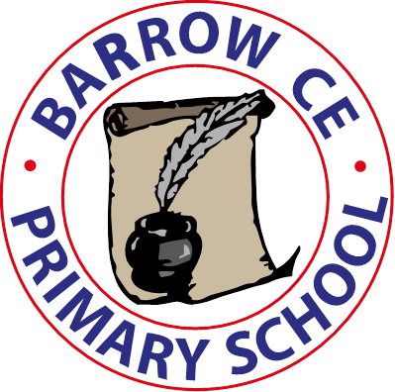

**Barrow C of E Primary School**

**School Term Dates 2023-24**

**Autumn Term 2023**

**Monday 4th September INSET Day**

Tuesday 5ndSeptember School re-opens

Friday 20th October School closes for half term

**Monday 30th October INSET Day**

Tuesday 31st October School re-opens

Friday 15th December School closes for Christmas holiday

**Spring Term 2024**

**Monday 1st January (Bank Holiday)**

**Tuesday 2nd January INSET day**

Wednesday 3rd January School re-opens

Friday 16th February School closes for half term

Monday 26th February School re-opens

Thursday 28th March School closes for Spring Break

**Summer term 2024**

**Monday 15th April INSET Day**

School re-opens Tuesday 16th April

**Monday 6th May Bank Holiday, school closed**

Tuesday 7th May School re-opens

Friday 24th May School closes for half term

**Monday 3rdJune INSET day**

Tuesday 4th June School re-opens

Wednesday 24th July School closes for summer holidays

**Autumn Term 2024**

**Monday 2nd September 2024 INSET DAY**

**Tuesday 3rd September school re-opens**