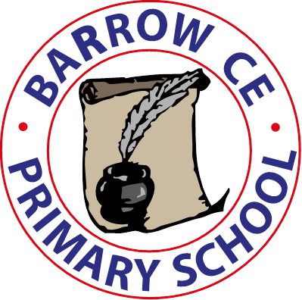

**Barrow C of E Primary School**

**School Term Dates 2024-25**

**Autumn Term 2024**

**Monday 2nd September INSET Day**

Tuesday 3rd September School re-opens

Friday 24th October School closes for half term

**Friday 25th October INSET Day**

Monday 4th November School re-opens

Friday 20th December School closes for Christmas holiday

**Spring Term 2025**

**Monday 6th January School INSET Day**

Tuesday 7th January School re-opens

Friday 14th February School closes for half term

Monday 24th February School re-opens

Friday 4th April School closes for Spring Break

**Summer term 2025**

Wednesday 23rd April School re-opens

Friday 23rd May School closes for half term

**Monday 2nd June INSET Day**

Tuesday 3rd June School re-opens

Tuesday 22nd July School closes for summer holidays

**Wednesday 23rd July INSET Day**

**Autumn Term 2025**

**Monday 1st September 2025**