Whole School Story Time
At Barrow CE School, we are determined that our pupils will develop a love of reading. One of ways to support this love of reading and stories is through our whole school story time where we enjoy a story together as a whole school family and learn about how reading can help us to learn, be inspired and be happy.
Every Friday, at the end of the day, the whole school gathers to enjoy a story together. We enjoy this time and it helps us to end the week with a relaxing story that helps our imagination to grow.
Children can listen to the stories again if they click on the links below.
Happy story time!
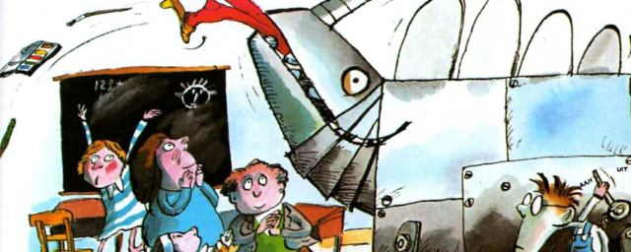
Boffy and the Teacher Eater
click here to listen to the story
When a teacher upsets his little friend, Boffy the child genius invents a special machine to gobble up all the teachers at school!
The last slice of rainbow
click here to listen to the story
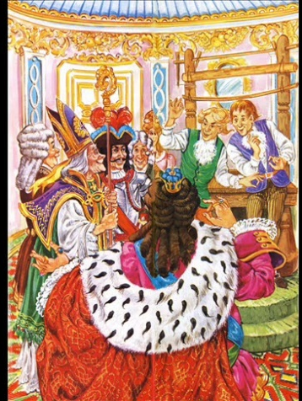
Jason is a boy who can see the wind and remember any tune. These remarkable powers lead to a very special day!

The Emperor’s New Clothes
click here to listen to the story
The story of the vain Emperor and his invisible suit of clothes is one of Hans Christian Andersen’s best-loved stories.

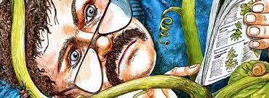
The Shoe Tree
click here to listen to the story
A strange thing happens when Mr Martin buries a boot in the garden!
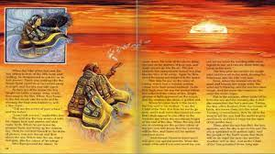
Child of the Sun
click here to listen to the story
Many legends are attempts to explain the wonders of nature in human terms. This Canadian tale tells of the passing seasons.

The Great Big Hairy Boggart
click here to listen to the story
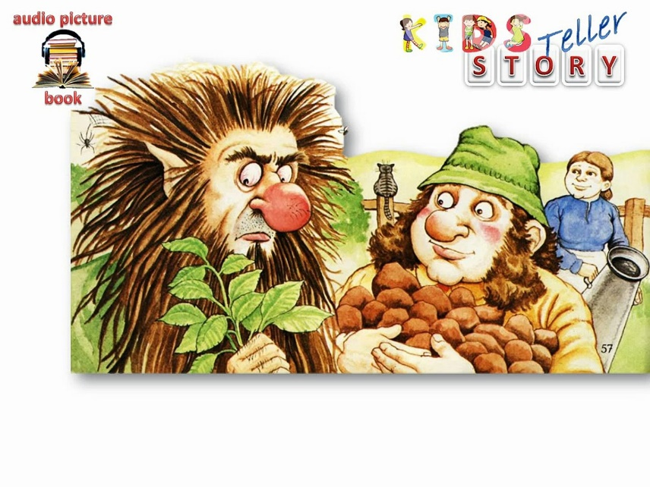
This story is set in Ireland and tells how a bad-tempered, dim boggart is outwitted by a farmer and his wife.

